Able to create a customer chatbot
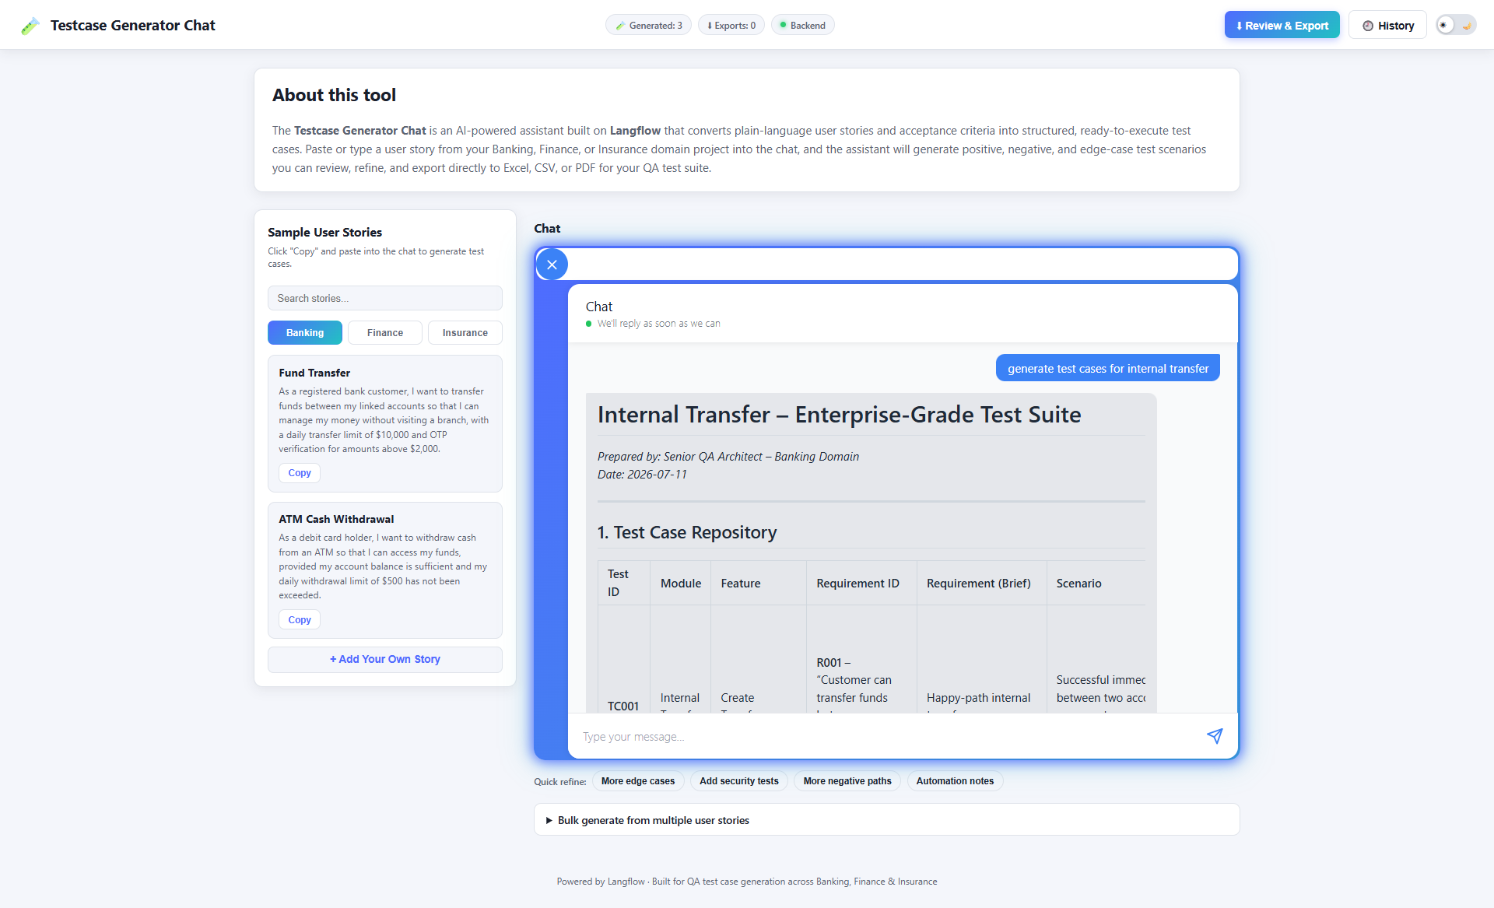
Features added
- Added Quick Refine buttons such as More edge cases, Add Security tests, more negative paths and Automation notes
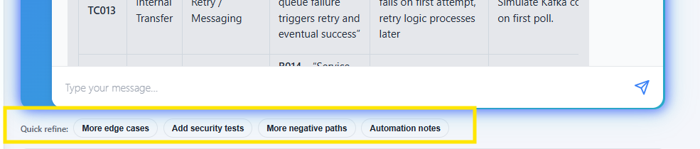

Clicking each will generate additional test cases
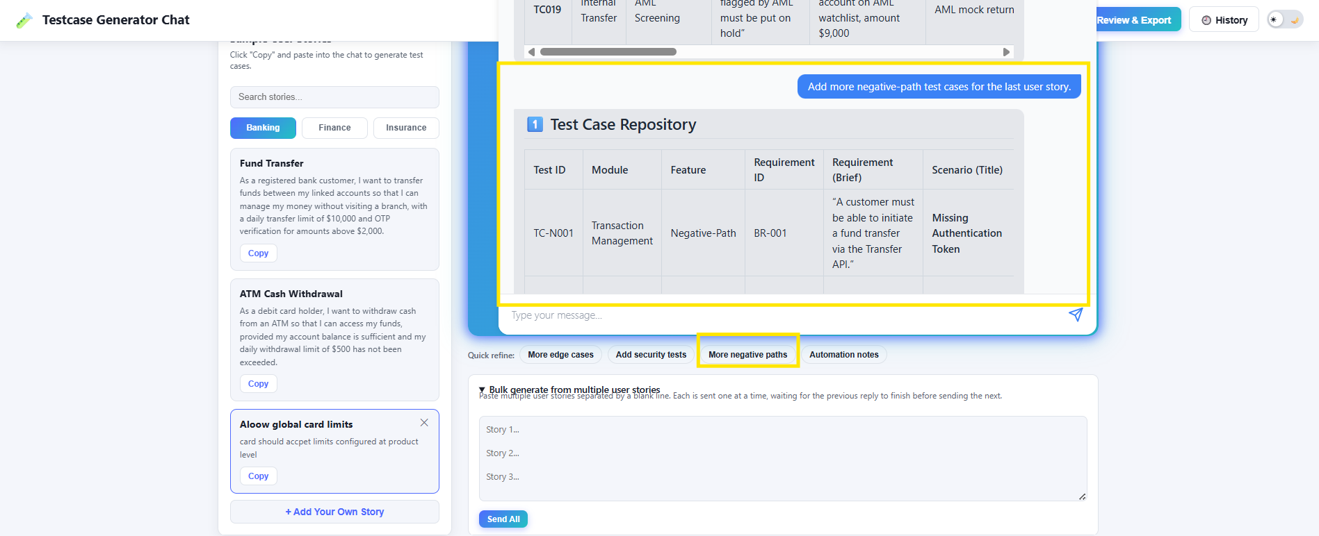

- Added Bulk Generate from Multiple User Stories
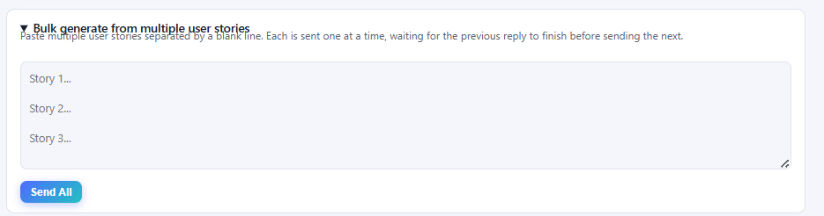

- You can add your own story to generate test cases
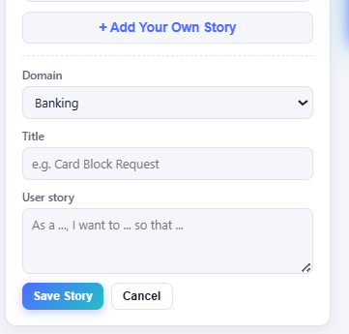
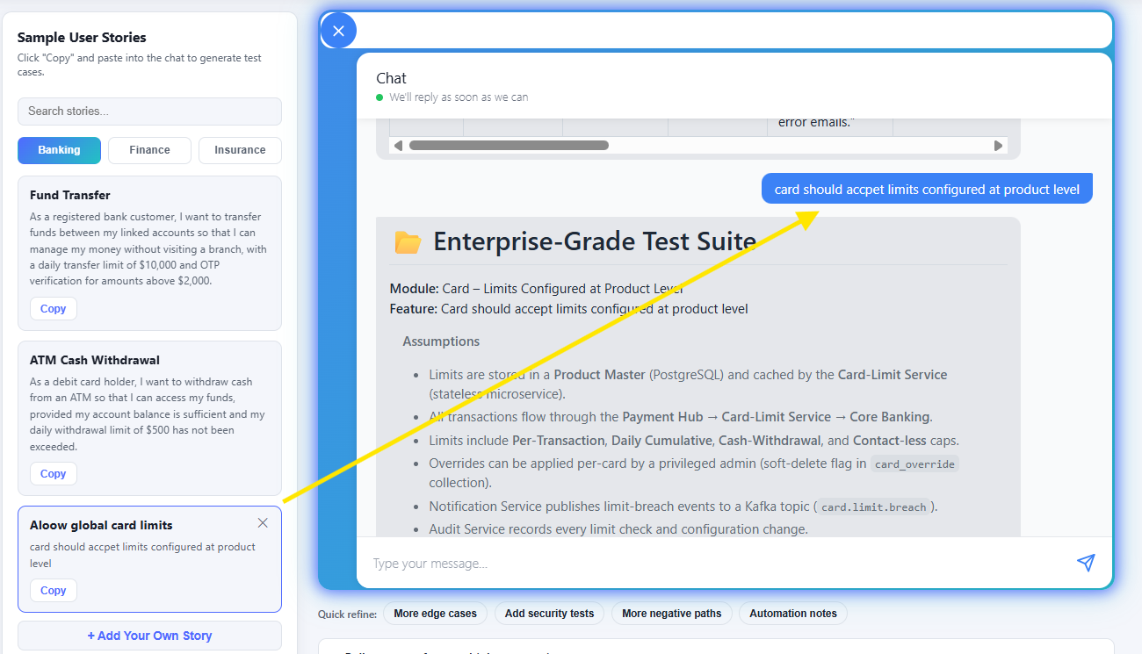

- On the top it shows no of time generated, no of exports and backend (Langflow) connection status
- Users can review the test cases before exporting
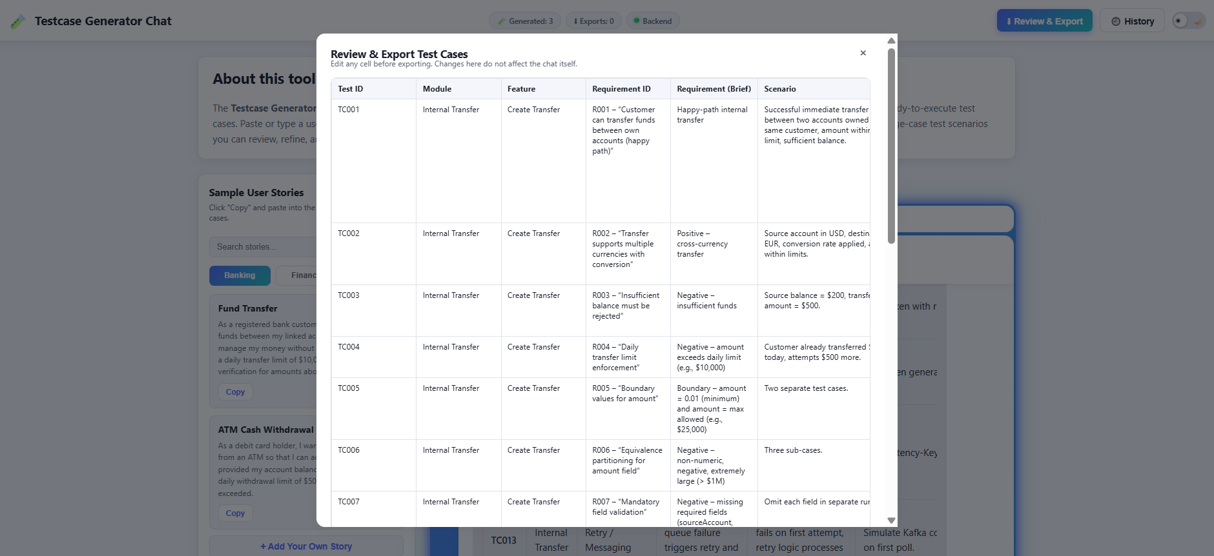
- Added manual entry of test cases and more export format options
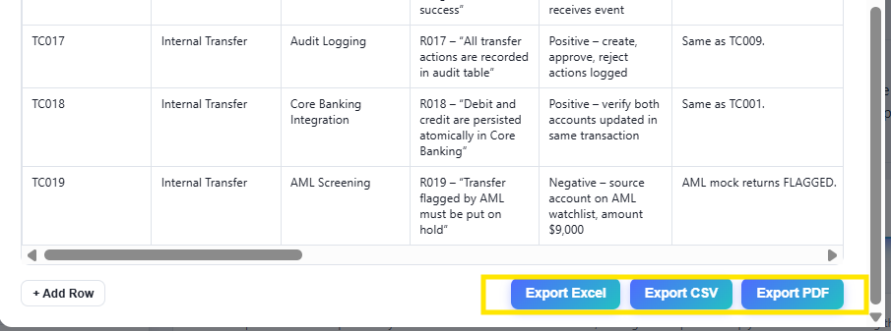

- Added option to view the export history and redownload button
